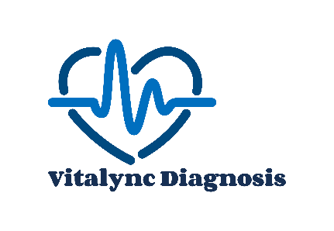
Terms & Conditions for Doctor Onboarding
These Terms & Conditions ("Agreement") govern the onboarding and participation of doctor on VitaLync Diagnosis. By registering and providing consultation services through our Platform, you agree to comply with these terms.

1. Eligibility & Registration
1.1 You must be a licensed and certified medical practitioner, holding valid credentials as per the applicable laws and regulations in the jurisdiction(s) you practice. 1.2 You must provide accurate personal, professional, and bank details during registration and update them as necessary. 1.3 You must have a valid Disclosure and Barring Service (DBS) registration to ensure compliance with legal and safety standards. 1.4 We reserve the right to verify credentials and reject or terminate any application or registration at our sole discretion.

2. Scope of Services
2.1 The Platform facilitates online consultations between Doctors and Patients. 2.2 You agree to provide professional, ethical, and timely medical consultations in compliance with applicable medical guidelines. 2.3 You shall maintain patient confidentiality and adhere to all applicable privacy and data protection laws. 2.4 You may also offer face-to-face consultations at a clinic owned and operated by You, subject to compliance with all relevant regulations.

3. Consultation Fees & Payment Terms
3.1 You may set your consultation fee, subject to any minimum or maximum limits prescribed by Us. 3.2 We shall deduct 20% of each consultation fee as a service commission before remitting the balance to You. 3.3 Payments shall be processed on a weekly basis and transferred to Your registered bank account. 3.4 Any applicable taxes, payment gateway charges, or deductions will be borne by You unless otherwise specified by law.

4. Cancellation & Refunds
4.1 In case of patient-initiated cancellations before the consultation, refunds shall be processed as per our refund policy. 4.2 If You fail to attend a scheduled consultation without prior notice, we may impose penalties, including fee deductions or temporary suspension.

5. Conduct & Compliance
5.1 You shall not engage in any fraudulent, unethical, or illegal activities on the Platform. 5.2 You agree to comply with all applicable medical laws and telehealth regulations. 5.3 Any misrepresentation, malpractice, or violation of these terms may result in immediate suspension or termination.

6. Liability & Indemnification
6.1 The Platform acts as an intermediary, and We are not liable for any medical advice, prescriptions, or services provided by You. 6.2 You agree to indemnify and hold Us harmless from any claims, damages, or liabilities arising from Your consultations. 6.3 We shall not be responsible for any technological failures, payment delays, or other unforeseen circumstances beyond our control.

7. Termination
7.1 Either Party may terminate this Agreement with 7 days prior written notice. 7.2 We reserve the right to suspend or terminate Your access if You breach any of these Terms. 7.3 Any outstanding payments shall be processed within 14 days post-termination.

8. Amendments & Governing Law
8.1 We reserve the right to update or modify these Terms at any time with prior notice. 8.2 Continued use of the Platform after modifications constitutes acceptance of the revised Terms. 8.3 This Agreement shall be governed by and construed in accordance with the laws of United Kingdom.

9. Contact Us
For any queries regarding these Terms, please contact us at 02036332371 or email at info@vitalync-diagnosis.com
By proceeding with the registration, you acknowledge that You have read, understood, and agreed to these Terms & Conditions.

